Exercise 1: Configuring a Basic Spring Application
Scenario:
Your company is developing a web application for managing a library. You need to use the Spring Framework to handle the backend operations.
Code:
BookRepository.java
public class BookRepository {
public void displayRepository() {
System.out.println("Book Repository Loaded");
}
}
BookService.java
public class BookService {
private BookRepository repository;
public void setRepository(BookRepository repository) {
this.repository = repository;
}
public void displayService() {
System.out.println("Book Service Loaded");
repository.displayRepository();
}
}
applicationContext.xml
<?xml version="1.0" encoding="UTF-8"?>
<beans xmlns="http://www.springframework.org/schema/beans"
xmlns:xsi="http://www.w3.org/2001/XMLSchema-instance"
xsi:schemaLocation="
http://www.springframework.org/schema/beans
https://www.springframework.org/schema/beans/spring-beans.xsd">
<bean id="bookRepository"
class="BookRepository"/>
<bean id="bookService"
class="BookService">
<property name="repository"
ref="bookRepository"/>
</bean>
</beans>
MainApp.java
import org.springframework.context.ApplicationContext;
import org.springframework.context.support.ClassPathXmlApplicationContext;
public class MainApp {
public static void main(String[] args) {
ApplicationContext context =
new ClassPathXmlApplicationContext("applicationContext.xml");
BookService service =
(BookService) context.getBean("bookService");
service.displayService();
}
}

Output:
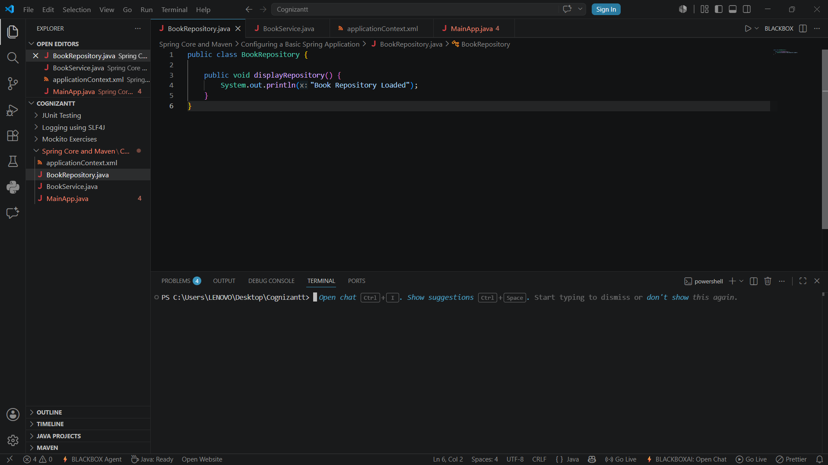

Exercise 2: Implementing Dependency Injection
Scenario:
In the library management application, you need to manage the dependencies between the BookService and BookRepository classes using Spring's IoC and DI.
Code:
BookRepository.java
public class BookRepository {
public void displayRepository() {
System.out.println("Book Repository Loaded");
}
}
BookService.java
public class BookService {
private BookRepository bookRepository;
public void setBookRepository(BookRepository bookRepository) {
this.bookRepository = bookRepository;
}
public void displayService() {
System.out.println("Book Service Loaded");
bookRepository.displayRepository();
}
}
applicationContext.xml
<?xml version="1.0" encoding="UTF-8"?>
<beans xmlns="http://www.springframework.org/schema/beans"
xmlns:xsi="http://www.w3.org/2001/XMLSchema-instance"
xsi:schemaLocation="
http://www.springframework.org/schema/beans
https://www.springframework.org/schema/beans/spring-beans.xsd">
<bean id="bookRepository"
class="BookRepository"/>
<bean id="bookService"
class="BookService">
<property name="bookRepository"
ref="bookRepository"/>
</bean>
</beans>
LibraryManagementApplication.java
import org.springframework.context.ApplicationContext;
import org.springframework.context.support.ClassPathXmlApplicationContext;
public class LibraryManagementApplication {
public static void main(String[] args) {
ApplicationContext context =
new ClassPathXmlApplicationContext("applicationContext.xml");

BookService service =
(BookService) context.getBean("bookService");
service.displayService();
}
}
Output:
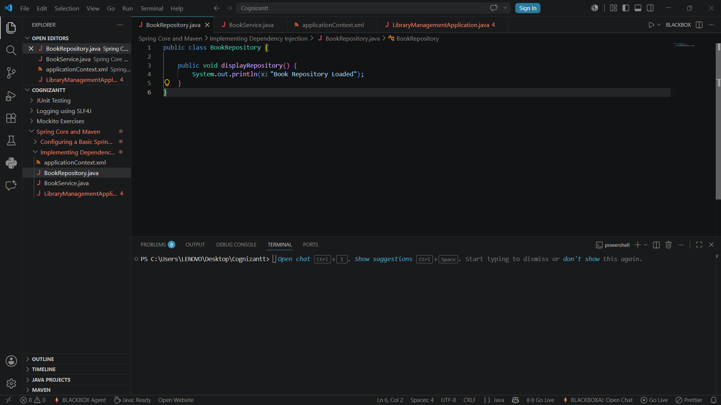

Exercise 4: Creating and Configuring a Maven Project
Scenario:
You need to set up a new Maven project for the library management application and add Spring dependencies.
Code:
pom.xml
<project xmlns="http://maven.apache.org/POM/4.0.0"
xmlns:xsi="http://www.w3.org/2001/XMLSchema-instance"
xsi:schemaLocation="http://maven.apache.org/POM/4.0.0
https://maven.apache.org/xsd/maven-4.0.0.xsd">
<modelVersion>4.0.0</modelVersion>
<groupId>com.library</groupId>
<artifactId>LibraryManagement</artifactId>
<version>1.0</version>
<dependencies>
<!-- Spring Context -->
<dependency>
<groupId>org.springframework</groupId>
<artifactId>spring-context</artifactId>
<version>5.3.30</version>
</dependency>
<!-- Spring AOP -->
<dependency>
<groupId>org.springframework</groupId>
<artifactId>spring-aop</artifactId>
<version>5.3.30</version>
</dependency>
<!-- Spring Web MVC -->
<dependency>
<groupId>org.springframework</groupId>
<artifactId>spring-webmvc</artifactId>
<version>5.3.30</version>
</dependency>
</dependencies>
<build>
<plugins>
<plugin>
<groupId>org.apache.maven.plugins</groupId>
<artifactId>maven-compiler-plugin</artifactId>
<version>3.8.1</version>
<configuration>
<source>1.8</source>
<target>1.8</target>
</configuration>
</plugin>
</plugins>
</build>
</project>
Output:
